Bronco ID: |0|1|3|4|8|4|6|7|9|

Last Name: Francisco

First Name: Serrano

1:

Part a:

Part b:

2:

<https://github.com/franserr99/cs4210/blob/main/a2/decision_tree_2.py>

3:

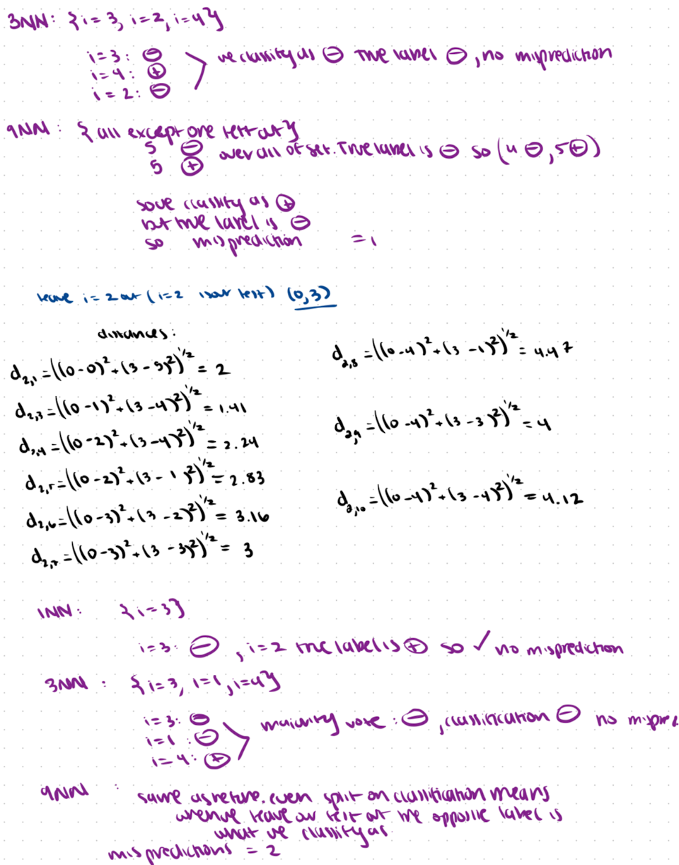

Part d:

Part e: <https://github.com/franserr99/cs4210/blob/main/a2/knn.py>

4:

5:Part a:

Part b:

<https://github.com/franserr99/cs4210/blob/main/a2/naive_bayes.py>